Roof Report
Customer Details
Customer name: Unique Building Services Pty Ltd
Work order: UBS-xxxxx
Site address: Site contact:

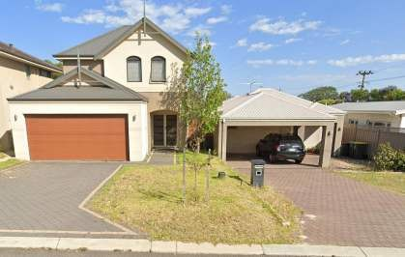

FRONT OF PROPERTY IMAGE

Scope of Works
Please attend for a Roof Report to determine the cause of damage into the garage

Trade Details

Company Name | (Trade Company)
Trade Name | (First and Last Name)
Trade Licence/Registration Number

Report Details

Report Type | Metal Roof Report
Service Provider
Inspection Date
Inspection Time

Property Details

Property type | Domestic
Height: | Single
Construction: | Brick
Approximate property age (years) as stated by site contact: | 40 □ Unconfirmed
General property condition: | Aged

Damage Details

Leak detected: | Yes
Location of leak: | Garage
Location of damage: | Multiple areas across the entire ceiling line.
The extent of damage (LxWxH L/m Sqm): | Multiple areas of water damage and missing ceiling board to the 5.6m x 5.3m x 2.6m garage.
Estimated time that the damage has been present for: | Long-term exceeding 1 year

Assessment Statement & Test Results:

Approximate age of the roof: | 40
General roof condition: | Poor
Roof pitch above area of damage: | 5.2
Roof pitch required to be in accordance with the minimumprofile / product (degrees): | 5
Roof pitch installed in accordance with the minimum profile / product as per NCC 2019 Building Code of Australia 3.5.1.3: | Yes
Roof condition above area of damage: | Poor
Roof profile: | Tray deck (Cliplok) □ Tray deck (Pierced fixing) □ Other □ Corrugated ☑
Tray deck sheets turned down sufficiently at gutter end: | N/A
Roof sheets weathered sufficiently at high end: | No
Roof sheet condition: | Good □ Fair for age □  Poor ☑ Creased □  Split □ Corroded ☑
Pierced fixing (screwed) rubber seal condition: | Good □ Deteriorated ☑ Over tightened □
Roof sheets engage rear of gutter by min 50mm: | N/A
Sarking installed: | No
Sarking extends to gutter line: | N/A
Storm created openings: | No
Ceiling insulation installed: | No
Ceiling insulation damaged: | N/A
Approximate amount of damaged insulation (Sqm):
Roof penetrations in accordance with, SA HB 39 section 8.6: | N/A
Spouting with no permanent ponding, in accordance with SAHB 39 5.6 (f): | N/A
Spouting outlet / downpipe clear; | N/A
Sufficient down pipes as per NCC 2019 3.5.3.5 | N/A
Sufficient provision for overflow of eave gutter, inaccordance with AS/NZS 3500.3 Appendix G: | N/A
Alternative overflow (a performance solution is required): | N/A
Adequate flashing covers, in accordance with SA HB 39 8.1.4:Horizontal 150mm Vertical 100mm | No

Fixing seal application in accordance with SAA HB 39  2.9:25mm lap, sealed between with 40mm fixing spaces | No
Adequate fixing spacing, wall flashings in accordance with SAHB 39 8.4: Compression flashing 100mm centers | No
Correct downpipe spreader, in accordance with SAA HB 395.7.7: | N/A
Reason down pipe spreader is non-compliant: | Spreader design non- Exceeds maximum compliant □ allowable catchment area  □  No sarking present □ Discharges onto flashing □  Discharges against the Discharges into a valley direction of flow □ gutter □  N/A ☑
Valley gutter: | N/A
Pitch of roof discharging into valley gutter not less than 12.5degrees as per AS 3500.3 3.6: | N/A
Valley gutter side angle not less than 16.5 degrees as per AS 3500.3 3.6: | N/A
Valley gutter roof catchment area does not exceed 20 sqm asper AS 3500.3 3.6: | N/A
Any storm related damage to the roof: | No
Windows, doors or any other opening spray test: | N/A
Any other tests conducted with results:

Cause of Damage

Installation defect ☑ | Age wear and tear ☑ | Lack of maintenance □ | Weather event e.g., storm  /wind □
Spillage □ | Vandalism □ | Vermin □ | Impact □
Unconfirmed □ | Other (refer to conclusion)  □ | No visible damages □

Continue to next page.

Conclusion
Upon arrival the site contact indicated the stand-alone garage was their only area of concern.

Multiple sheets of ceiling boards have collapsed with water staining to the walls and timber framing throughout showing clear evidence of water damage.
Assessment of the roof noted it to be in a very poor condition.
The roof has multiple flashings detached from the structure allowing clear access for water to enter. No gutters have been installed at the discharge point of the metal roof.
Areas of surface rust, lapped roof sheets/dissimilar metals and deteriorated flashings are all directly resulting with water damage to the below garage.

Any other concerns or unrelated issues
N/A

Recommendations
- Engage a suitable roof plumber to replace the roof and install a gutter connecting to the existing down pipe.
- Engage a suitable builder to determine the best method for internal repairs.

NOTE:
Buildings constructed prior to 1990 do not have to comply with AS/NZS 3500.3 Buildings constructed prior to 1992 do not have to comply with AS HB 39
Any alterations or replacements after the above years must comply with the current standards.

Disclaimer: As the weather conditions under which the water ingress occurred cannot be replicated, this conclusion is based only on evidence visible during today’s inspection. Defects noted in the above assessment statement that are not in accordance with applicable Australian Standards, may be acceptable if a performance solution is provided by the installer.

Please include a cost estimate for repairs like the example below:
Estimated Cost of Repairs

Description Quantity Unit Price GST Amount AUD
Prepare and paint exterior eaves, fascia, posts, 12.00 45.00 10% 540.00
and rafters

Materials 1.00 183.00 10% 183.00
Subtotal 723.00
TOTAL GST 10% 72.30

TOTAL 795.30
AUD

Photos
Aerial image of the affected garage

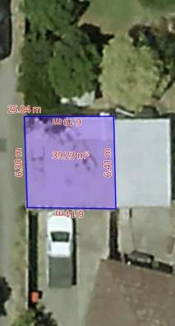

OH&S requirements – safety harness and point of attachment

Internal damages of collapsed ceiling to internal garage
Roof pitch compliant.

Roof related defects.
- Corroded roof sheets
- Overlapped roof sheets of dissimilar metals.
- No guttering.
- Non-compliant/unsealed/fixed flashings.
